Thanom Chapakdee
Dharma Group
The Dharma Group was founded in Thailand in 1971 by a group of mostly self-taught artists; Pratuang Emjareon was elected as leader. The group was formed around the concepts Nature, Art, Truth and Virtue, with members believing that these should be developed and explored through human interactions and the individual experience of the artist. However, as a result of Thailand’s political and social turbulence of the 1970s, set in motion by the student uprisings of 1973 and 1976, the Dharmma group focused on the need to develop new ideas that reflected the socio-political context. Influenced by Socialist Realism, along with other groups they adopted the slogan “Art for Life, Art for the People,” reflecting their belief that art and life should be inseparably linked. This was the first time in Thailand that art was produced to express social concerns, rather than the populist, conservative art produced by the country’s Academies. The Dharma group aimed to express the feelings and struggles of working people and tried to give them a voice through visual art. What made it so important was that it galvanised self-taught artists in a movement which really awakened pride in Thai contemporary art circles. Even today many art students and art academics passionately participate in the group’s activities.
Dharma-Nature was the first exhibition of Dharma Group, it took place in 1971in the E.T.O. building, Klong Teoy port. The exhibition included the group’s eleven members including, Pratuang Emjareon, Supan Krachangpen, Winai Sakchareon, Niti Wattuya, Boonying Emjareon, Chaiwat Wananon, Pakde Limpong. In 1975, the group’s second exhibition, a conceptual exhibition of paintings, was held at the Old Royal Mint. In 1976, the Dharma Group, reflecting their beliefs in “Art for Life, Art for the People”, began to exhibit independently of art academic institutions, and thereby acquired great artistic and political significance. Mostly the works dealt with widespread poverty, anti-imperialism, anti-capitalism, homelessness, suffering and struggles. At this time, several artists joined the Dharma Group to show their works at the Bhirasri Institute of Modern Art in Sathorn Road. Works in this exhibition included Pratuang Emjareon’s Orchardman’s Smile (1976), Seni Stone (1976), Wishes on the Moon (1976), Chokchai Takpho’s The Bread (1976), Niti Wattuya’s The Buffalo (1976). The works of Thammasak Booncherd, Winai Sakjareon, Boonying Emjareon, Wirote Nuibutr, Nonthasak Pasaratool, Payab Pundukrut were also shown. Exhibiting socially engaged works on the theme ‘Art of the People’ (Silapa Khong Prachachon) was controversial at this volatile stage in Thailand’s political history, a stage which reached its apex on October 6 1976 with the massacre of student’s at Thammasat University,
After the dramatic changes in Thailand’s political situation after 1976, the Dharma Group continued their artistic activities. To the present day, artists and numerous guest artists have participated in the Dharma group’s activities and the group has remained influential as an exemplary self-taught artists’ group for over 40 years.
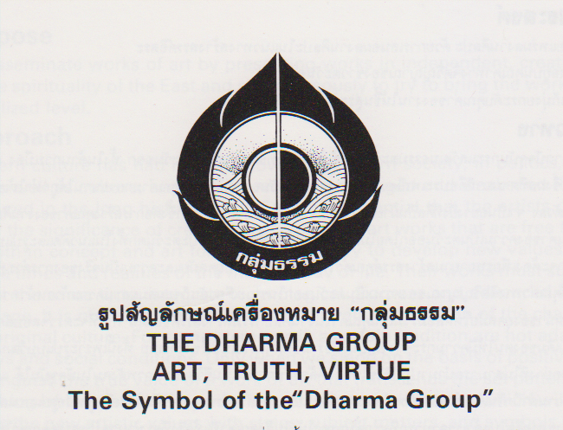
Dharma Group’s Symbol
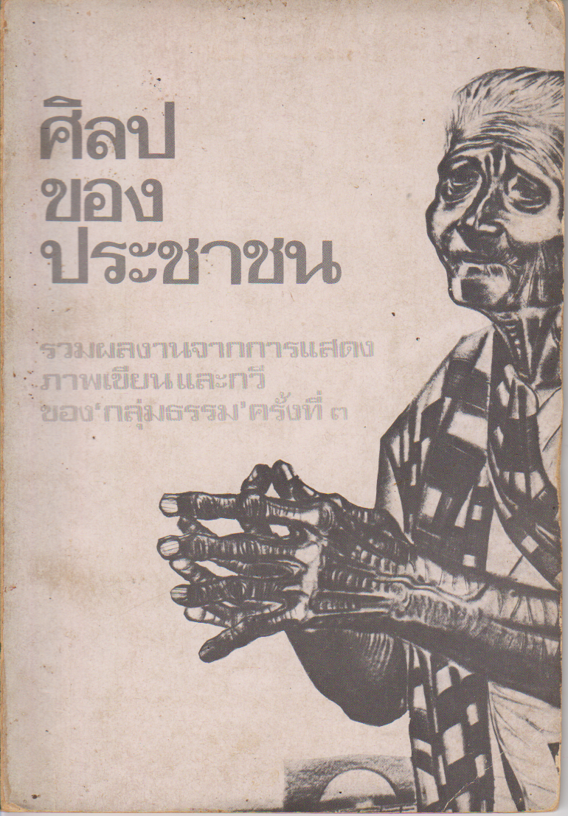
Cover of The Third Dharma Group Exhibition, Catalogue in 1976.
References and Further Reading

-----. (1976). Art of the People. (Silpa Khong Prachachon): The Third Dharma Group Exhibition, (exhibition catalogue in Thai). Bangkok: Bhorpit.

-----. (1989) Nature and Life: The Dixth Dharma Group Exhibition Bangkok: Amarin Printing Group.

-----. (1995). Name-Form: The Ninth Dharmma Group Exhibition, Bangkok, Amarin Printing Group.

Poshyananda, Apinan. (1992) Modern Art in Thailand : Nineteenth and Twentieth Centuries. New York: Oxford University Press.

